|  |  |  |  |  |  |
| --- | --- | --- | --- | --- | --- |
| No. | Name | Description | Weight | Category | Mitigation Approach |
| 1 | Player Interest | If not enough players are interested in playing the game or not enough players are interested to keep playing the game, then people won’t be playing the game resulting in loss of profits. | H | Business | 1.Create marketing campaigns to help advertise the game  2.Create new downloadable content to create more interest in players new and old. |
| 2 | Underage Account  Creation | If the player creating the account is under 18, then the company may face some legal issues. | L | Business | 1.Ask for date of birth upon account creation |
| 3 | Project Completion on Time | If the project isn’t complete by the deadline, then players won’t be able to purchase the game and stakeholders won’t be happy. | H | Schedule | 1.Make sure the team and project are on track to finish before the deadline |
| 4 | Memory  Requirement | If the player does not have sufficient memory in their system, then the game may not run as smoothly and can ruin the player’s experience. | L | Technical | 1.Create system requirements showing the required amount of memory needed.  2.Write efficient code to decrease the required amount of memory |
| 5 | Account Fraud | If a player is able to make more than one account, a player can manipulate the system to increase their win percentages. | M | Technical | 1.Player must be in presence of system administrator in order to create the account. |
| 6 | Player Turn Fairness | If a player who knew the system went first every turn, then the player would automatically win | L | Technical | 1.Player turns are determined by who is farthest from winning. |
| 7 | Player forfeits game | If the more than 50% of the player base has quit the game, then the lone player left would automatically be declared winner. | M | Technical | 1. System recognizes which players has left the game, and takes note of which players left and adjusts game for it |
| 8 | Equal High scores when game ends | If by the end of the game, two or more players are equal in score, the game decides the winner by the most buildings created by that one player. | L | Technical | The system recognizes which players are equal in score, and goes into backup plan for most complex, and quantifiable amount of buildings created. |

|  |  |  |
| --- | --- | --- |
| Date | Phase | Info |
| 10/01/18 | Inception | Added initial Risk List |
| 10/29/18 | Elaboration 1 | Updated weight and categories for our use cases. |
| 12/08/18 | Elaboration 2 | Updated to add a new fully dressed of player forfeits game, and use case of equal high scores when endgame. |

INCEPTION PHASE RISK LIST AND MANAGEMENT PLAN 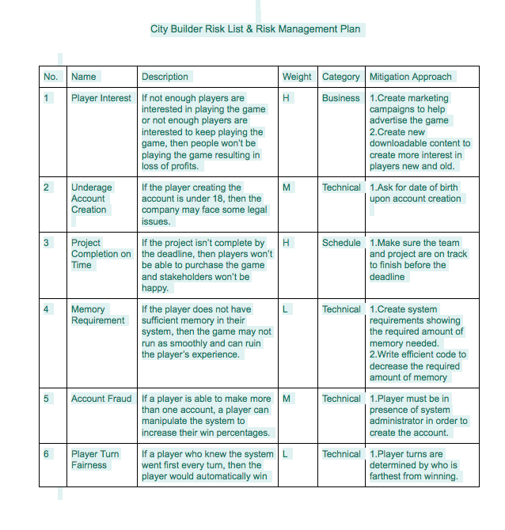

Our Inception phase Risk list saw a few changes from our elaboration phase. We changed from the Underage Account creation risk being to a more business risk, as our marketing could be affected. It is up to how we deliver the game in public that determines if underage kids will play the game. We added two new technical risks in being players quitting the game, and the off chance of multiple players having equal high scores in the end. Players quitting has a medium risk as the chances of rage quitting can occur when one gets frustrated. The other change is adding the risk of not immediately knowing who wins due to equal scores. In this case which is a low risk, the game determines who did the most of buildings, and complexity of using resources